**BLOOD DATABASE MANAGEMENT SYSTEM**

**THE PROJECT REPORT**

**Submitted For**

**The Partial Fulfilment of**

**BCA (4THsemester)**

**By**

**1.Ishika Ojha [S.N : 343327]**

**2. Sabin Siwakoti [S.N :]**

**3. Garima Khanal [S.N :]**

**Under the keen supervision of**

**Mr. Bhawesh Kafle**

**GOMENDRA MULTIPLE COLLEGE**

**Anarmani-4, Birtamode, Jhapa, NEPAL**

**PREFACE**

Welcome to the world of computer, this is the age of computer, so it becomes essential to every sector have its own software due to this we have developed program which will be fruitful for Red Cross Society or any other blood related organization. Blood Database Management System, it is our approach to add creation in the computer theoretical as well as the practical knowledge which we have acquired during the study on 4th semester. We are glad to work on this project due to favourable environment provided by our teachers, college and mutual framework between our group members. For the development of any information system, lots of information and raw data are required, which is collected from different sources. The application of data files is essential for the data to be stored permanently for future reference. Keeping this in mind we are much careful in learning the concept of record handling using C# desktop application from the very beginning of BCA 4th semester.

A number of programs we have developed and executed on C# visual studio during the course. The practice session on programming took an important role in developing the current project. In spite of the availability of a very limited time and our involvement with the preparation of the theoretical papers, we tried our very best to involve ourselves as much as possible in our developing stages.

The brief introduction about this program is mention in the INTRODUCTION content.

Comments and suggestions for the development of this whole project are mostly welcome.

**PROGRAMMER’S DETAILS AND SYMBOL NO.**

|  |  |  |
| --- | --- | --- |
| **NAME** | **SYMBOL NO.** | **ADDRESS** |
| Ishika Ojha | 343327 | Surunga |
| Sabin Siwakoti |  | Goldhap |
| Garima Khanal |  | Birtamod |

**SYNOPSIS**

In this project we have mainly learnt about the real life experience of doing live project. This project has helped us to develop self-confidence in implementing our technical knowledge into reality.

Blood Database Management System is a desktop application program in Database. This project was done to face the real world problem rather than being bound within theoretical knowledge. This project help us how to use Visual Studio C#(Desktop application) programming, how to analysis the user requirement and how to achieve the system objective in the real world.

The outmost thing we have learnt is to cope up with the real world and achieve the system objective in the real world.

**Chapter 1**

**INTRODUCTION**

In today’s world, the way for functioning and managing the system has been totally changed. There is a sudden and abrupt change in structure, maintenance and modification, handling, levelling inside every system. Without managing system through computer applications and programming, the developments of infrastructures are unfinished. There are many errors and drawbacks without use of computer programming and applications.

It’s is true, “necessity is the mother of invention”. So, in today’s challenging world, every system is developed and launched by the use of software and programming. In the field of medical the use of software is increasing as the increasing rate of new medical treatment. As the part of medical the database management system of blood group is one small part of medical world, so we have prepared our project on i.e. “**Blood Group Database Management System**”, which deals with the basic record of, id ,name of blood donor, types of blood , modifying details, deleting details, searching details, viewing details.

This application will be very useful in blood donation program conducted by organization for the welfare of humankind. This application is very much useful for blood donation program that conducted at any place by any social organization. To keep the record of donor.

**PROPOSED SYSTEM**

“**Blood Group Database Management System”** is a simple application, which is especially generated and designed for the blood donation program which are conducted by any social organization in order to enter the donor’s basic record and information and can perform other functions like addition, viewing, searching, modification and deleting if required. It is username and password protected as well.

**OBJECTIVES**

Following are the major objectives behind the new proposed system:

* It creates user friendly environment, where a normal user can easily access through all the benefits of the system.
* It provides security from unauthorized access, only admin or authorized users are access granted to this system.
* It increases efficiency and saves the time.
* Easy access of saved data inside the system.

**SYSTEM FEATURES**

* Since the program is simple and user can access it.
* It reduces time and cost of association.
* The person who has little knowledge of computer can operate this software.
* This software can run with minimum hardware requirements.

**SYSTEM LIMITATION**

* Only a single person can work on this program.
* It is exclusively command-based program.
* Users can’t enjoy a lot due to least graphic environment.
* The system does not work in network environment.
* The system cannot perform huge information.

**LIST OF TABLES AND FORMS IN PROGRAM**

**NAME OF TABLES:**

* tbllogin
* tblAddRecord

**NAME OF FORMS:**

* Dashboard
* Login
* Sign Up
* Add Record
* Edit
* Search
* View
* Delete data

**JOBWISE SCHEDULE**

**Student Name: Ishika Ojha**

|  |  |  |  |  |
| --- | --- | --- | --- | --- |
| **JOB ID** | **JOB DESCRIPTION** | **DATE FROM** | **DATE TO** | **REMARKS** |
| A1 | Coding/ designing | May 15th | May 28th |  |
| A2 | Documentation | May 24th | May 29th |  |

**Student Name: Sabin Siwakoti**

|  |  |  |  |  |
| --- | --- | --- | --- | --- |
| **JOB ID** | **JOB DESCRIPTION** | **DATE FROM** | **DATE TO** | **REMARKS** |
| A1 | Designing | May 10th | May 20th |  |
| A2 | Documentation | May 25th | May 29th |  |

**Student Name: Garima Khanal**

|  |  |  |  |  |
| --- | --- | --- | --- | --- |
| **JOB ID** | **JOB DESCRIPTION** | **DATE FROM** | **DATE TO** | **REMARKS** |
| A1 | Research | May 5th | May 20th |  |
| A2 | Documentation | May 25th | May 29th |  |

**Algorithms**

* Step 1: Start.
* Step 2: Enter username and password.

If matches go to step 3.

If it doesn’t matches show the message “login failed”.

. Step3:create new account using sing up.

* Step 4:Open the main form containing the features to Add, View, Edit, Search, Delete and other options.

If Add man record is selected open Add Record form

If View is selected open View form.

If Edit is selected open Edit form.

If Search is selected open search Form.

If Delete is selected open delete Form.

* Step 5:do operation as mention on form.
* Step 6:Exit.

**CONCLUSION AND FURTHER WORK**

Finally, we are success to create the project in Visual Studio 2019 and SQL Server 2016 for database. Our knowledge and skill now comes in work. We are very glad and happy because we meet our success point. All the activities of project like documentation, coding are successfully carried in the certain period.

This experience of carrying our project, entitled “ **BLOOD GROUP DATABASE MANAGEMENT SYSTEM**”, will help us in developing big projects in coming days. We, the beginners of BCA 4th semester are hopeful and confident that with the learning of many more topic related to such development work, we will be able to do something better in our future projects in upcoming semesters.

All feedback is very welcome- let us know what you found useful and what you found not-so-useful and what additional information you would have liked to be included in future program.

We are thankful to the management of our college for this creative work.

Without their cooperation it would not be possible to complete the project. We would like to express our gratitude to all colleagues who helped us by providing valuable suggestion. We take pleasure to present this project on SQL . It’s very challenging for us to develop project on SQL without any previous knowledge.

We would like to thank to our supervisor **Mr. BHAWESH KAFLE** for this creative and great support. We would also like to thank all our colleagues and principal of this college. Finally thank you all individual who have assisted and encouraged us in the developing of this project.

**REFERENCE**

[**www.google.com**](http://www.google.com)

**Lecturer: Mr. BHAWESH KAFLEY**

**Text book**

**VIEW OF PROJECT**

**Login Form**

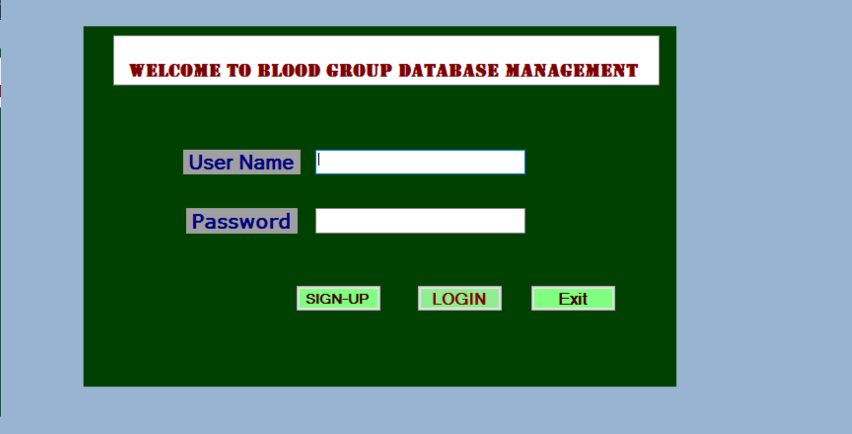

**Sign-Up**

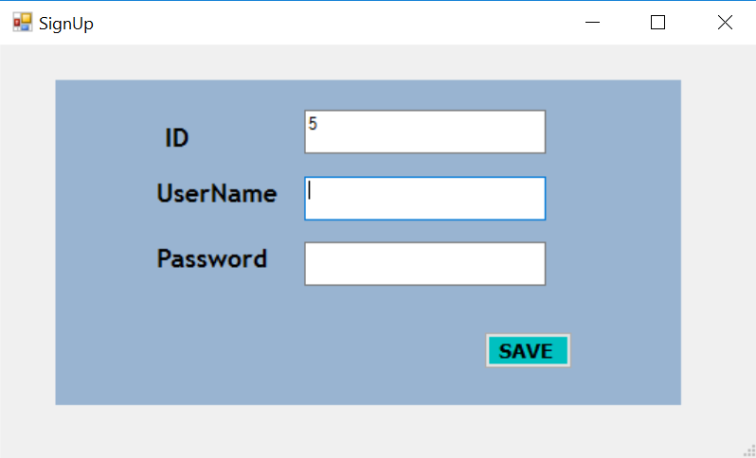

**DashBoard**

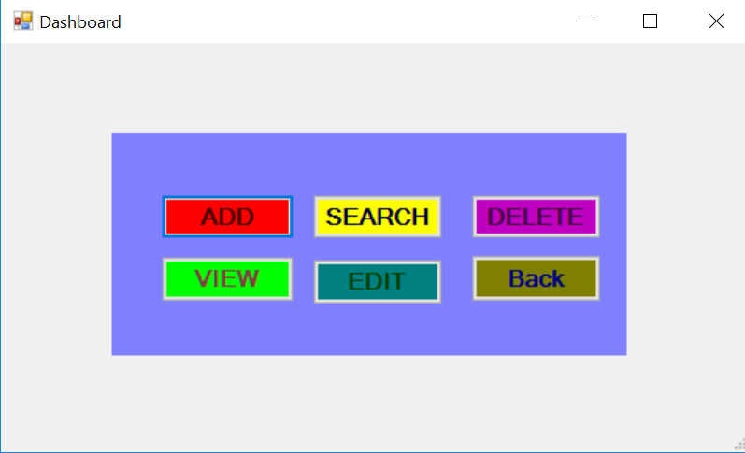

**AddRecord**

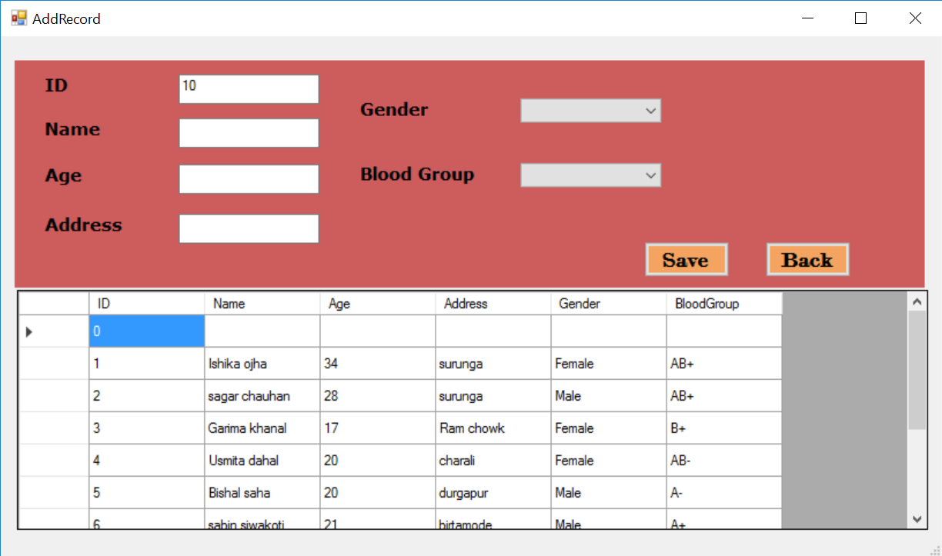

**View**

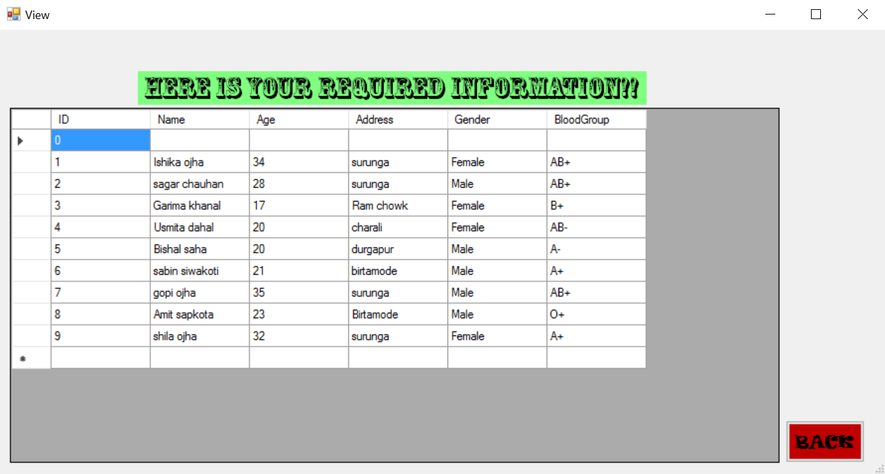

**Search**

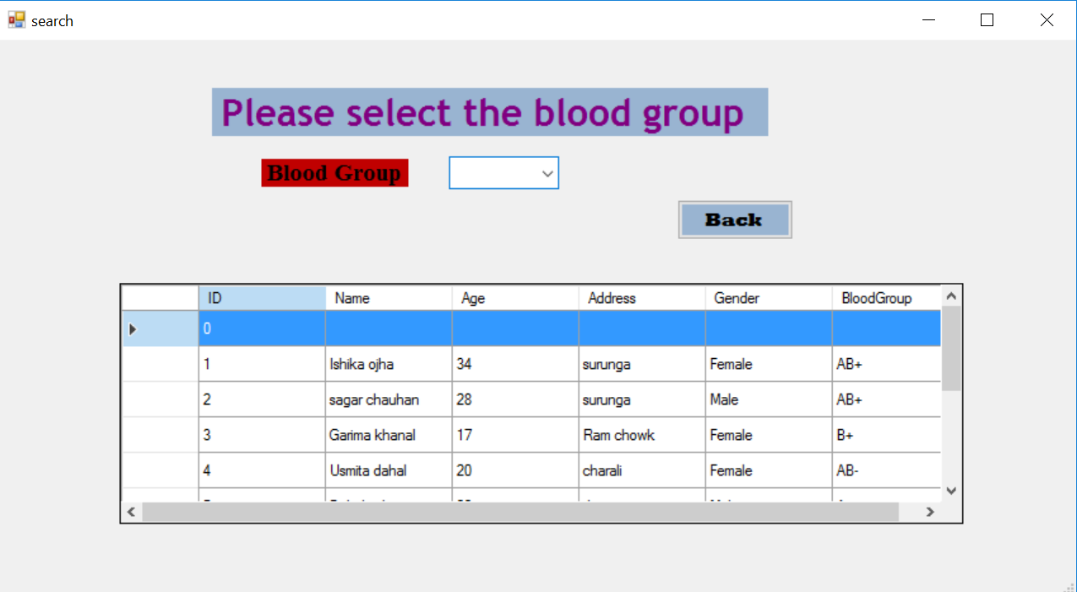

**Edit**

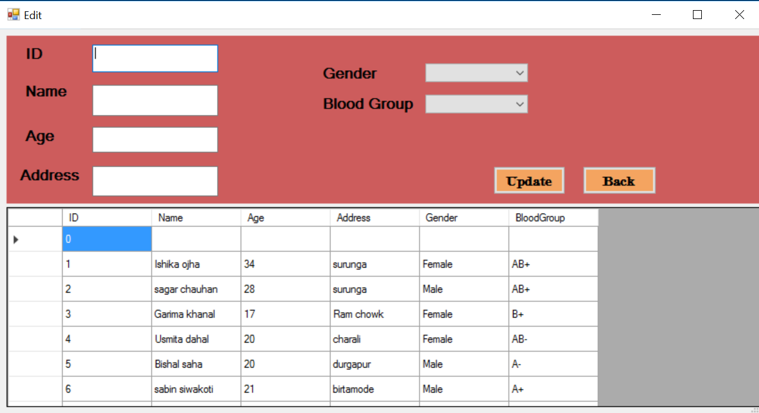

**Delete**

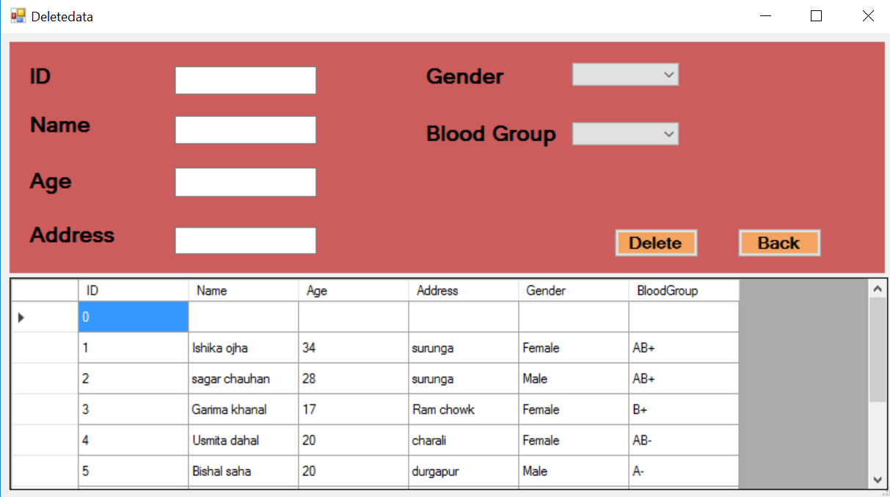

**Thank you!**